SESSION — ACTIVITY (20 MIN) • STUDENT HANDOUT • SLOT C
Redesign the Misleading Colored Chart
R.No: 1 Reg. No: 192524157 Name: A Lokesh Kumar
Each chart below uses color in a misleading or confusing way. For each one, answer the three questions in your own words. Chart 1
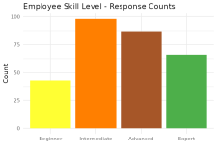
1. What is this chart trying to show?
_________________________________________________________________________________
2. What's wrong with the color choice?
_________________________________________________________________________________
3. Propose a better color scheme (describe it in words):
_________________________________________________________________________________ Chart 2
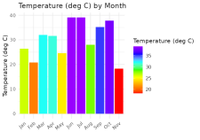
1. What is this chart trying to show?
_________________________________________________________________________________
2. What's wrong with the color choice?
_________________________________________________________________________________
3. Propose a better color scheme (describe it in words):
_________________________________________________________________________________
